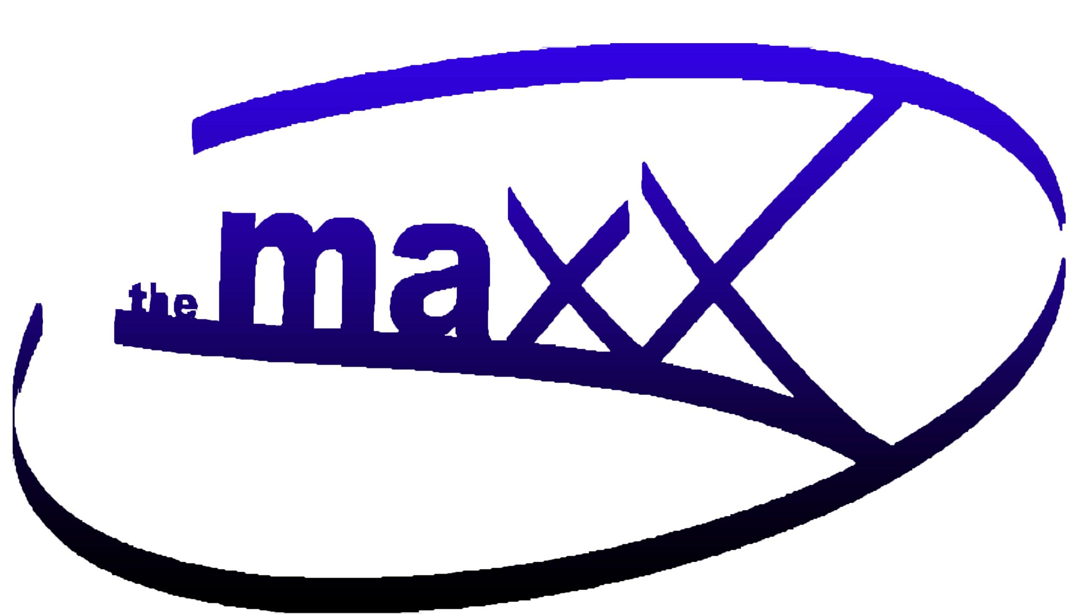
*RENTAL RATES FOR 4 HOURS
Private Groups
*One Room $200.00 *Both Rooms $300.00
(Hourly rate is available upon request - depending on scheduling)
Private Groups extra time over 4 hours - $40.00 per hour
*Rental rates are for 4 hrs. This includes your setup and break-down time. Included are any chairs, tables and use of bathroom facilities
Non Profit Groups: $75.00 / 2-hr increment
Any fees associated with use of the Maxx must be paid, in full, two (2) business days prior to the start of the event or when Maxx keys are picked up.
Notice of cancellation of events must be made 24 hours in advance (48 hours if the event is scheduled for Sunday). Any event cancelled without notice, will forfeit all rental fees. There will be no cancellation fee charged when cancellation is due to inclement weather. \

Xbox - $30.00 package fee - includes Xbox One controllers and games. NBA 2k22, Madden 2022,
Minecraft, Fortnite

Kitchen Use- $50 grants access to kitchen and equipment. If using kitchen for commercial use (selling food), please provide a Food Safety Manager Certificate from an approved testing organization by the local Health Dept - ServSafe®
With all kitchen rentals, a $100 retainer is required either by cash or check which will be returned to renter if no visible damages or misuse of the kitchen upon completion of rental.
Linens: white tablecloths for round / banquet tables: $5 per table we have twelve / 5’ round,
two 8ft tables, seven 6ft table, 85 chairs

